**Screenshots for E-mail IDs Validation Project:-**

**GitHub Reciprocity Link**:- https://github.com/kapildavey/Phase1.git

**Screenshot of E-mail id Valid:-**

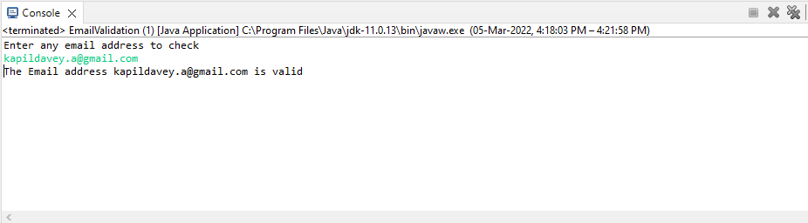

**Screenshot of E-mail id Invalid:-**

